UNIVERSITY OF ENGINEERING AND TECHNOLOGY



Culinary Arts Academy Website Project

SUBMITTED BY:
FATIMA BHATTI
ZAINAB AMIR
AZKIA RIAZ
USAID SHAHID
EMAN SARFRAZ

SUBMITTED TO:
MISS RAMSHA

Executive Summary
This project presents a production-ready culinary education website developed using semantic HTML5 and external CSS. The Culinary Arts Academy website serves as the central digital platform for promoting professional cooking classes, providing detailed course information, pricing, schedules, and contact details. The website is designed to be responsive, accessible, and visually professional, and it acts as the primary content source for related academic deliverables including a Word brochure, Excel enrollment tracker, and PowerPoint presentation.

Project Objectives & Scope
The main objective of this project was to design and implement a fully functional culinary education website using only HTML5 and CSS, without JavaScript. The scope includes presenting class offerings, institutional information, student outcomes, and a structured contact interface. The website targets beginner to advanced learners interested in culinary arts and supports both academic demonstration and real-world deployment.

Site Structure & Navigation
The website uses a single-page layout with clear navigation links anchored to key sections:
Home: Hero section introducing the academy and call-to-action.
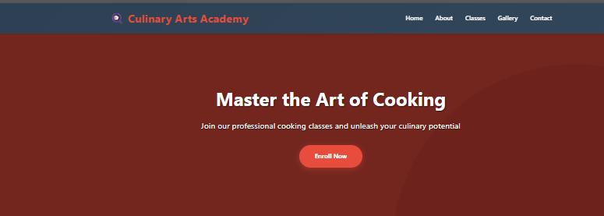

Figure 1: Homepage of Culinary Art Academy
- About: Academy background, mission, and statistics including 5,000+ students trained and 98% satisfaction rate.
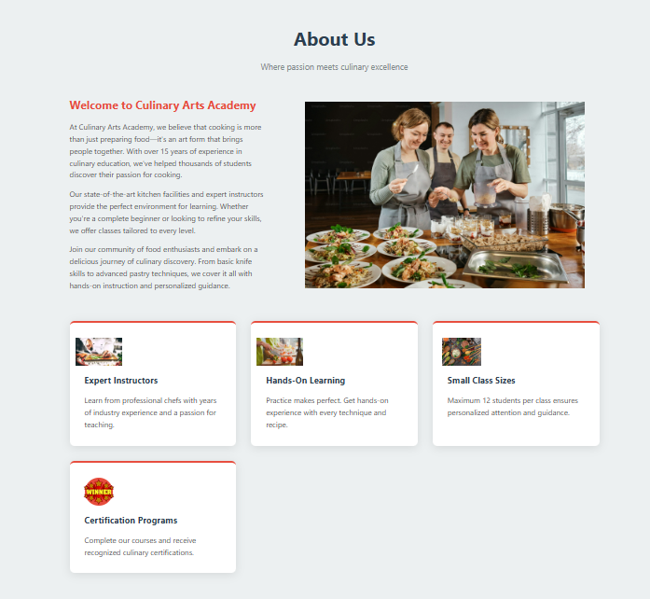

Figure 2:About Section
- Classes: Detailed class offerings with duration, schedules, and pricing.

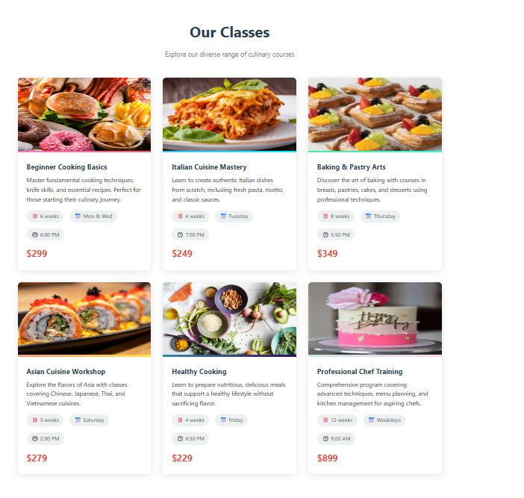
Figure 2: Classes Section
- Gallery: Student creations and class activity samples with captions
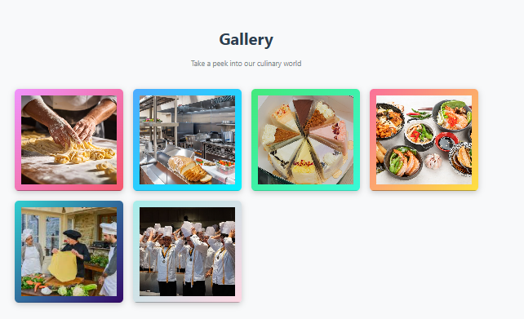
- figure 3: Gallery Section

- Contact: Address, contact details, social links, and an HTML-only contact form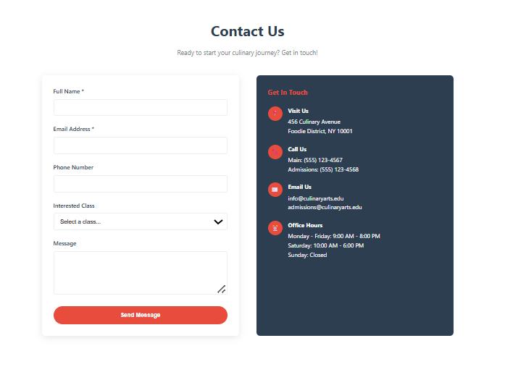 -

Design Choices
The website uses a clean and professional visual identity focused on readability and hierarchy. Typography is based on modern, web-safe sans-serif fonts. The layout uses CSS Grid and Flexbox to organize navigation menus, class cards, gallery items, and contact sections. A responsive design approach ensures usability on mobile and desktop devices, with structured sections, consistent spacing, and clear call-to-action buttons.

Assets Used
All visual elements are represented using semantic placeholders and captions. Gallery sections include labeled examples such as 'Fresh Pasta Making', 'Pastry Perfection', 'Knife Skills Practice', and 'Plant-Based Feast'. No external image libraries were required. All numerical data such as class prices, durations, and schedules are original and used consistently across Excel and PowerPoint deliverables.

Quoted Figures for Excel & Slides
The following figures are used consistently across all project deliverables:
Course Name | Duration | Schedule | Price (USD)
Italian Cuisine Mastery | 4 weeks | Tuesday, 7:00 PM | $249
Beginner Cooking Basics | 6 weeks | Mon & Wed, 6:00 PM | $299
Baking & Pastry Arts | 8 weeks | Thursday, 5:30 PM | $349
Asian Cuisine Workshop | 5 weeks | Saturday, 2:00 PM | $279
Healthy Cooking | 4 weeks | Friday, 6:30 PM | $229
Professional Chef Training | 12 weeks | Weekdays, 9:00 AM | $899

How to Run / Publish the Site
To run the website locally, open the HTML file in any modern web browser. For publishing, upload the HTML and CSS files to a static hosting service such as GitHub Pages or Netlify. Ensure that the CSS file path (styles.css) remains in the same directory as the HTML file.

Reflection
Through this project, valuable experience was gained in structuring semantic HTML5 documents, implementing responsive layouts using CSS Grid and Flexbox, and designing professional academic deliverables. Future improvements could include backend form handling, image optimization, accessibility audits, and multi-page navigation for scalability.

Live URL
Screenshots of the Home, Classes, and Contact sections should be inserted here.
Live Site URL: ____________________________

